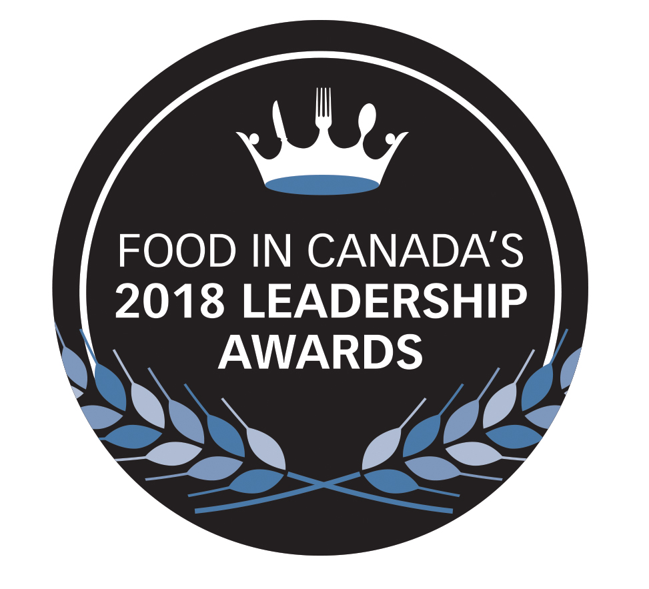
Food in Canada’s 2018 Leadership Awards
Presented by Grant Thornton LLP

Food in Canada’s 2018 Leadership Awards, presented in partnership with Grant Thornton LLP, recognize outstanding food and beverage processing companies that demonstrate leadership in the Canadian food industry through:

- Strong and continued business growth
- A focus on innovation
- The development of healthy products
- Environmental and social stewardship efforts
- Community and industry involvement

This year we will be awarding companies which shine in ALL five areas. We will also be recognizing one company for its Community and Industry Leadership, and one “Rising Star,” a young but growing business with sales of less than $3 million.

Winners will be profiled in the April 2018 issue of Food in Canada.

All Canadian-based food and beverage producers and processing companies, pet food processors, agri-food companies, and food and beverage distributors and importers will be considered (suppliers to the industry will be considered if they are also a producer/processor for retail or foodservice). An emphasis will be on those companies that demonstrate success in all areas of their business, including but not limited to: continual product innovation and design; expansion into new domestic or international markets; development of people and culture; production efficiency; financial growth; community involvement and support; an emphasis on healthy product development; responsible stewardship of resources; and strong progressive leadership within the company and within the food and beverage industry.
Please complete the information requested in the attached pages, as well as any supporting information (please do not send videos or products) and submit electronically (PDF or Word document) to ccooper@foodincanada.com or by hard copy to Carolyn Cooper, Food in Canada, 38 Lesmill Rd., Unit 2, Toronto, Ont., M3B 2T5. Unfortunately we will not be able to return any submitted material.

Entries must be received by midnight Jan. 31, 2018

More information can be found at www.foodincanada.com/award, or email questions to ccooper@foodincanada.com. Phone inquiries will not be answered.
GENERAL INFORMATION
Company name
Street address 1
Street address 2
City
Province
Postal Code
Contact name & title
Contact phone number
Contact email & company website
General description of business

ELIGIBILITY REQUIREMENTS
To be eligible to enter Food in Canada’s Leadership Awards, companies must meet the following criteria:
- Must be a food and beverage producer or processor, pet food processor, agri-food company, food and beverage distributor or importer suppliers to the industry will be considered if they are also a producer/processor for retail or foodservice).
- Companies (either private or public) must be headquartered in Canada.
- Companies must be majority Canadian-owned, or a subsidiary of a foreign-owned company with facilities in Canada.
- Companies must have been in business for three years or more.
- Companies must have achieved annual revenue in the last fiscal year of at least $3 million.
- Companies applying as a “Rising Star,” may be less than three years old, with sales of less than $3 million.

JUDGING CRITERIA
Submissions will be evaluated in each of the areas listed below. Please note that the following categories include suggestions of the types of criteria the judging panel will be considering, rather than criteria that entries must meet. Entries that satisfy more selection criteria may receive a higher overall score from the judging panel. Financial information is an important and quantifiable indicator of success for the judging panel. It is encouraged that financial metrics be included where appropriate.

All information will remain private, and will only be reviewed by the judging panel. All decisions are at the discretion of the judging panel, and are final. Evaluations and decisions made by the judging panel other than for the award winners will not be made public and will not be released to any entrants. Entrants may be contacted for further information or to review submitted information.

Please consider the following suggestions when making your submission. Information may be entered here, or included in additional documents:
A) Growth:
Company demonstrates strong overall achievement, continued expansion, history of strong financial growth, expansion into new domestic or international markets, and efficiency in productivity. Company demonstrates a significant turnaround from financial difficulties in the past year, or extraordinary financial or market growth in the past several years.

B) Innovation:
Company demonstrates the successful launch of a new product(s)/product line or service(s) in the past year, with strong consumer engagement and buy in. Company demonstrates commitment to R&D and/or new category development. Company has an ongoing history of innovation and consumer engagement, with an emphasis on new products or services launched in recent years.

C) Social & Environmental Stewardship:
Company demonstrates ongoing commitment to positive sustainable practices in areas such as, but not limited to, ingredient sourcing, packaging, recycling, waste and wastewater management, energy management, environmental awareness, production and sourcing methods.

D) Community & Industry Leadership:
Company demonstrates strong involvement with the food industry and its community through awareness of and leadership in social issues. Company demonstrates socially responsible sourcing and engagement with the communities in which it sources ingredients. Company demonstrates a healthy corporate culture, with the promotion of employee development as well as health and safety within the workplace. Company has a strong positive reputation within the food and beverage industry, and good working relationships with suppliers and stakeholders.

E) Health & Wellness:
Company demonstrates a commitment to providing products that are healthy and nutritious and which offer a “clean label.” Companies have undertaken significant changes or reformulations of its products or a product line to offer consumers healthier alternatives. Company is committed to consumer education with the goal of promoting healthy eating. Company is a leader in promoting R&D in the health and wellness category within the food industry.

All winners will be contacted in mid-February. Winners must be available in February for interviews. Profiles of each of our category winners will appear in the April 2018 issue of Food in Canada in print and online.

Name |  | Title
Signature |  | Date
By submitting this application, you agree that (i) you have read and agree to these rules and regulations; (ii) you have complied with all eligibility requirements; (iii) the Award will be accepted as presented; (iv) the information they are submitting is true, complete and accurate; (v) the information being submitted as part of the application process will be used by Grant Thornton LLP and Food in Canada in conjunction with the judging panel in selecting Award recipients and consent for such purpose is herein provided; (vi) Grant Thornton LLP and Food in Canada shall have the unrestricted right to produce, reproduce, publicize, broadcast, exhibit, distribute and otherwise use in any fashion, the winner’s name and any photograph, voice or likeness of any personal representative thereof whose consent the winner will be responsible for obtaining, for advertising and publicity purposes without any additional compensation; and (vii) Grant Thornton LLP, Food in Canada and Business Information Group and their respective officers, directors, members, partners, principals and employees are hereby released from any and all liability, loss, damages or cost related to participation in the Award process or the acceptance, use or misuse of the Award. Grant Thornton LLP and Food in Canada assume no liability for any lost, late, illegible, falsified, misdirected or incomplete entry, notification, reply or the unauthorized use of or access to same, or for any technical malfunction, loss or delay in data transmission, omission, interruption, deletion, defect, damage or failure of any computer, equipment, software, website, email, server, online system, network, lines or browser related to or resulting from participation in the Award. Grant Thornton LLP and Food in Canada assume no liability whatsoever for any loss, damage, cost, injury or claim howsoever caused.

